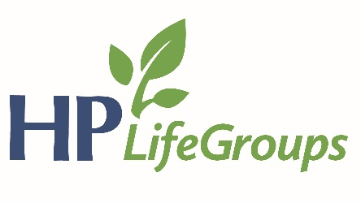

2018 HPBC Goals
- Individual Community Involvement: We will endeavor to cultivate a culture of evangelism in our church this year by encouraging our members to advance the gospel through individual community involvement.
  - Specifically: We desire for our members to pursue a level of community involvement that brings them into regular contact with those who need Christ. “Community involvement” can be as simple as engaging a neighbor through a common hobby or as complex as participating in or leading a formal community organization (sports leagues, HOA, charities, etc).
- Church Family Gathering: We will continue our goal from last year to devote ourselves as a church family to the practice of prayer, testifying, and discipling one another during our evening gathering.
  - Specifically: In addition to private and small group settings, we desire to see our church practice the commanded disciplines of prayer, testifying, and discipleship as an entire church family together. Our vision is for these practices to be essential and primary activities during our evening gathering. We will begin the process of structuring our evening gatherings to centralize around these activities.
Reflect
- Sunday AM – Nahum – Reality Check – Drew Conley
  - Possibly start off by reading Nahum.
  - How does this prophet compare and contrast with Jonah? What's the point of this comparison/contrast?
  - What are major themes in Nahum? Where do we specifically see some of those?
  - Does the language of God’s judgment in this prophecy make you uncomfortable? Why? What does this teach us about God?
  - What sins against others do we overlook in our current culture? What about even in the church? Are there areas in which we “look the other way” when we see people mistreated? Where have you seen this in your own life (taking advantage of someone less fortunate than you)?
  - What things are going on in your life right now that make it difficult for you to trust God?
  - What does it mean that God is our “refuge”? What does it not mean?
  - In groups of 2-3:
    - What is your main “takeaway” from this sermon?
    - Is there anything in your life that’s making it difficult for you to trust God right now?
    - How can we pray for each other?
- Sunday PM – Proverbs – Insights for Our Age: Authority, Trust, Humility – Drew Conley
  - Read Prov 29:27 - What ways do you see that we live in a divided age? Can you see particular ways in which this “divided age” has even infiltrated the church?
  - Read Prov 21:31 - What is the primary teaching of this verse?
    - What bearing does this have on our daily decisions?
    - "While science and technology can tell you what can be done and how to do it in the most efficient way, they cannot tell you whether you should do it or not. They can't tell you if something is or bad for human life because such things cannot be determined by technology, only by moral wisdom." -Keller
  - Read Prov 22:20-21 - What are the main "sources" of authority in our current day? In other words, where do people go to find the answer to something/anything?
    - Where do you often go to find an authoritative word on something?
      - How do you evaluate it?
  - Read Prob 15:25 - How does this apply to those in authority?
    - Have you ever used the authority that you have in an unhelpful way, taking advantage of someone else? How so?
  - In groups of 2-3:
    - In what settings do you struggle with authority (family, gov’t, church, etc.)? Why? What causes the struggle?
    - Pray for each other.

