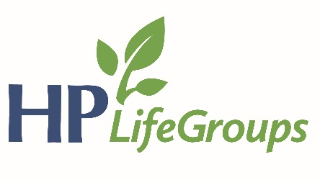

2019 HPBC Goal
We will endeavor to cultivate a culture of evangelism in our church by partnering with key community organizations to advance the gospel within the context of Christian care.

Specifically: We desire for our church body to partner with 3 key community organizations that demonstrate care for our community. It is our desire that these partnerships will provide channels through which our church members advance the gospel.

To find out more about each community partner, go here: https://www.hamptonpark.org/ministry-partners/

Reflect
- Sunday AM – Luke 6:37-49 – Seeing Who I Really Am – Drew Conley
  - How do we see ourselves in the sight of God? How should we see ourselves?
  - Why do we often fail to see our own sin? Are you sensitive to your sin? Are doing anything about it/what can you do?
  - How should we confront someone with sin?
  - Why don’t we confront our brother or sister in sin? Are we afraid to receive it back on us?
  - How do you want to be treated if you are in sin?
  - Why do many people see the church as a place full of hypocrites? How do our actions reveal our heart?
  - What does this lesson look like in my life?
  - Why do we need to pray and meditate on scripture? What does this (praying/meditating) look like in your life? Do you need to change in this area? What daily practices can you do to help you see sin for what it really is.
  - In groups of 2-3:
    - What sins does Satan dangle in front of me that I need others to help me for fighting against it? (Where am I prone to sin)
    - Is there anything specific that I need to repent of?
    - How can we pray for each other this week in regards to this message from Luke?
- Sunday PM – Acts – Activating Our Mission: Jerusalem – Joel Gearhart
  - Drew’s concluding questions from this sermon, based on the four “pillars” he pointed out from the church at Jerusalem (in Acts):
    - Priority of Prayer—How are you making public and private prayer a priority in your life?
      - Acts 1:14; 2:42; 3:1; 4:31; 6:4
    - Power of Proclamation—What are you doing to make the public and private proclamation of the Word a priority in your life—both hearing it and speaking it?
      - Acts 2:40-41, 42; 3:11-12; 4:4, 8-12; 5:19-21a, 42; 7; 8:4
    - Productivity of Suffering—What suffering are you enduring to advance the gospel in the lives of others?
      - Acts 4:27-29; 5:18, 40-41; 7:58; 8:1
    - Activity of Love—How are you showing your love for other believers in practical, tangible ways?
      - Acts 2:44-45; 4:32-34; 6:1; 8:2

This goal represents step 3 of 3. The first step in 2017 was to pray for at least 2 people who need Jesus and for an opportunity to present the gospel. Last year, our second step was encouraged our members to advance the gospel through individual community involvement. This year, our third step is for our church as a whole to partner with key community groups to advance the gospel within the context of Christian care. We desire for HPBC to use our resources in such a way to make an impact on our community for the cause of Christ and the good of those around us.

