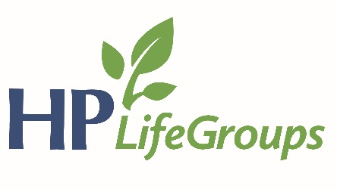

2019 HPBC Goal
We will endeavor to cultivate a culture of evangelism in our church by partnering with key community organizations to advance the gospel within the context of Christian care.

Specifically: We desire for our church body to partner with 3 key community organizations that demonstrate care for our community. It is our desire that these partnerships will provide channels through which our church members advance the gospel.

To find out more about each community partner, go here: https://www.hamptonpark.org/ministry-partners/

Reflect
- Sunday AM – Luke 6:12-36 – Downside Up – Drew Conley
  - Jesus prayed a lot. Talk about the significance of this.
    - In particular, talk about the significance of Jesus praying in this context (12-16).
  - Why is it significant WHO Jesus chose as his disciples (12-16)? Is this encouraging to you?
    - Can you think of any other passages of Scripture that emphasize that God chooses to do amazing things through ordinary people?
  - How valuable is prayer to you? Do you pray much? Do you find it valuable enough to make time for it and to persevere in prayer on a regular basis?
  - Are there things that would be difficult for you to give up in order to follow Jesus (possessions, reputation, wealth, etc.)?
  - Have ever found yourself struggling and working for worldly comfort more than or at the expense of your relationship with God? Anyone willing to share your experience and how God brought this to your attention?
  - Who are your enemies, that you can love? Let's expand the question to this: who are those that our world would lead us to think are our enemies that we can choose to love?
  - Is there anyone around you that you can show love to who will not be able to repay you?
  - In groups of 2-3:
    - What’s your main takeaway from this teaching?
    - Pray with each other.
- Sunday PM – Acts – Activating Our Mission: Acts Overview – Joel Gearhart
  - What did it look like in the lives of those who were first given the mission?
  - What is the meaning of the “go” in the Great Commission passages? Why is that significant for us?
  - Christians in the early church boldly proclaimed the gospel message (Acts 17:1-4). What may prevent us from boldly proclaiming the gospel in 2019?
  - Do we doubt the power of the gospel? If so, why?
  - What should our obedience to the Great Commission look like today? This week?
  - Why has God chosen to see His mission accomplished this way?
  - Discipleship is leveraging all that I am and all that I have so that someone else may become more like Jesus. How can you disciple specific “someone else’s” in your life this week?
  - How can our LifeGroup become more and more like a greenhouse for one another’s spiritual growth?

This goal represents step 3 of 3. The first step in 2017 was to pray for at least 2 people who need Jesus and for an opportunity to present the gospel. Last year, our second step was encouraged our members to advance the gospel through individual community involvement. This year, our third step is for our church as a whole to partner with key community groups to advance the gospel within the context of Christian care. We desire for HPBC to use our resources in such a way to make an impact on our community for the cause of Christ and the good of those around us.

